**PROJECT DESIGN PHASE-II**

**TECHNOLOGY STACK (ARCHITECTURE & STACK)**

|  |  |
| --- | --- |
| Date | 03 October 2022 |
| Team ID | PNT2022TMID13620 |
| Project Name | Corporate Employee Attrition Analytics |
| Maximum Marks | 4 Marks |

**TECHNICAL ARCHITECTURE:**

The Deliverable shall include the architectural diagram as below and the information as per the table1 & table 2

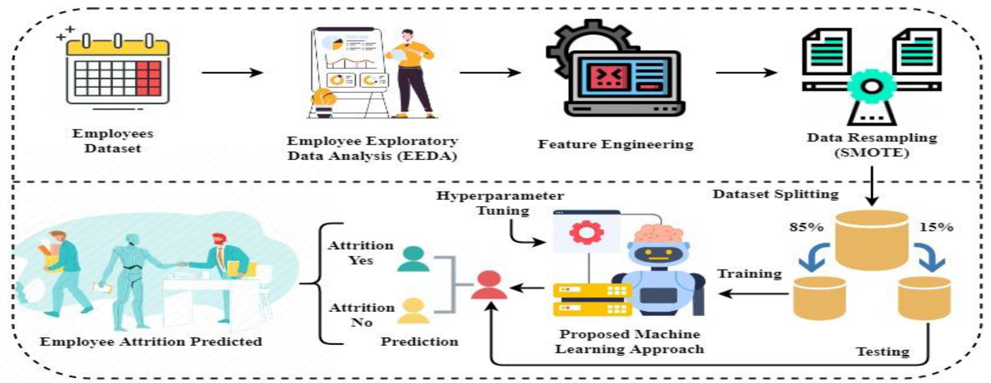

**Table-1 : Components & Technologies:**

|  |  |  |  |
| --- | --- | --- | --- |
| **S.No** | **Component** | **Description** | **Technology** |
|  | User Interface | Allows the user to enter the input and recognise the input using GUI | HTML,CSS, JavaScript |
|  | Digit Prediction | Here the digit given as a input is predicted. | Keras,CNN. |
|  | Representation | Skeleton, counters, pixels or others | Java / Python |
|  | Segmentation | Task of clustering parts of an image together that belong to the same object class | Convolutional neural networks & super pixels. |
|  | Machine Learning Model | Purpose of Machine Learning Model is to train and test the data and predict the user input.. | Classification. |
|  | Infrastructure | Application deployment on local system Local server Configuration: Intel core i5/i3 10th Generation. | HTML, CSS |
|  | Neural network | Automatically infer rules for recognizing handwritten digits | Convolutional neural network |

**Table-2: Application Characteristics:**

| **S.No** | **Characteristics** | **Description** | **Technology** |
| --- | --- | --- | --- |
|  | Open-Source Frameworks | IBM provides tools for simple to complex visualisations to be implemented | IBM Cognos Analytics |
|  | Security Implementations | It provides Exclusivity and is only ever share-able from your own account | Encryptions, IAM Controls, OWASP etc |
|  | Scalable Architecture | It is capable of handling very large datasets | Cognos Analytic |
|  | Availability | Clicking on the shared link redirects you to the data visualisations as long as | Cognos Analytic |
|  | Performance | It is a simple tool that can be used to achieve complex and large visualisations with ease | Cognos Analytic |

**References:**

[**https://c4model.com/**](https://c4model.com/)

[**https://developer.ibm.com/patterns/online-order-processing-system-during-pandemic/**](https://developer.ibm.com/patterns/online-order-processing-system-during-pandemic/)

[**https://www.ibm.com/cloud/architecture**](https://www.ibm.com/cloud/architecture)

[**https://aws.amazon.com/architecture**](https://aws.amazon.com/architecture)

[**https://medium.com/the-internal-startup/how-to-draw-useful-technical-architecture-diagrams-2d20c9fda90d**](https://medium.com/the-internal-startup/how-to-draw-useful-technical-architecture-diagrams-2d20c9fda90d)